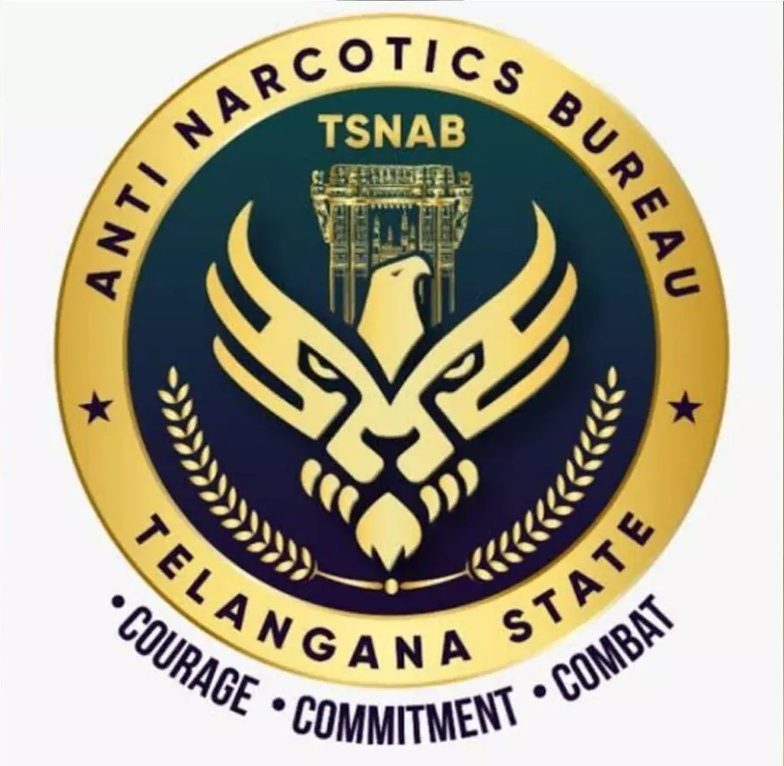
PRESS NOTE

NABBED (01) NIGEIRAN DRUG PEDDLER AND SEIZED ECSTASY (M.D) DRUG PILLS – 264 AND TWO CELL PHONES,
TOTAL WORTH OF RS. 10.56 LAKHS.

On 16-08-2023, the sleuths of TSNAB along with Film Nagar Police, Hyderabad City apprehended (1) Nigerian National by name Ogbaugu David Uka, @ Pastor Davison @ Iwu, who found in possession of psychotropic drug i.e., Ecstasy (M.D) Pills in the limits of Film Nagar PS, seized (264) Ecstasy Pills, all worth Rs. 10.56 Lakhs from him.

DETAILS OF THE ACCUSED:

Ogbaugu David Uka, @ Pastor Davison @ Iwu, aged 58 years, Occ: Barber, (Drug Supplier), R/o. Bangalore and N/o. Nigeria.

SEIZED PROPERTY:
- 264 Ecstasy (M.D) Pills.
- (02) Cell phones.

PREVIOUS CASE:

1) Cr. No. 315/2021 U/s 21 (b) 8 (c) NDPS Act of DJ Halli PS, Bangalore,
Karnataka.

M.O & CASE DETAILS:

The accused Ogbaugu David Uka, @ Pastor Davison @ Iwu is a kingpin in drug supply at Bangalore City and stays in Bangalore, simultaneously he has contacts with drug peddlers in Hyderabad city and frequently travels to Hyderabad. In the recent past seven drug peddlers were arrested in two different crimes registered at Kachiguda PS and KPHB PS are getting psychotropic drugs from the above accused and they were selling to the consumers in Hyderabad city. The accused exposed himself to the general public as Pastor and in the guise of Pastor he is serving as welfare chairman to the “ALL INDIA NIGERIAN STUDENTS & COMMUNITY ASSOCIATION”. The main functions of association are to arrange bails and other legal assistance to the arrested drug offenders of Nigerian Nation. He uses fabricated identity cards with fake names to conceal his identity. He also using a fake VISA. He took SIM cards on the name of others and using them for his criminal activities.
Contd..2nd page.,

:: 2 ::

On credible information on 16.08.2023 when he came to Hyderabad city to supply Ecstasy Pills to his known peddlers, the sleuths of TS NAB along with Film Nagar PS staff apprehended him and seized 264 Pills from his possession worth Rs.10.56 Lakhs and registered a case in Crime No.240/2023 U/s 8(c) r/w 22(c) of NDPS Act-1985 of Film Nagar PS, Hyderabad.

APPEAL TO THE GENERAL PUBLIC:

In recent times we have seen several youth/students getting addicted to Drugs/Ganja, committing crime and involving in other anti-social activities. Several families have become victims of this menace. It is an ardent request from TSNAB, Hyderabad City Police to the youth/students not to fall prey to drugs/Ganja and request the parents to keep a watch on the activities of their children and feel free to approach Police or pass information to Police on Phone No.8712671111 to curtail such anti-social activities and strive for Drug free City.
The above arrests were made under the supervision of Sri Gummy Chakravarthy, SP TSNAB by Sri P. Ramesh Reddy, Inspector of Police, TSNAB and staff of TS NAB along with Film Nagar Police.

DIRECTOR,
TS ANTI NARCOTICS BUREAU, (TSNAB) HYDERABAD.

